ГКОУ РД «Щедринская СОШ Тляратинского района»

ЦОДОУ ЗОЖ

Конспект урока английского языка в 7 классе

«**Food**»

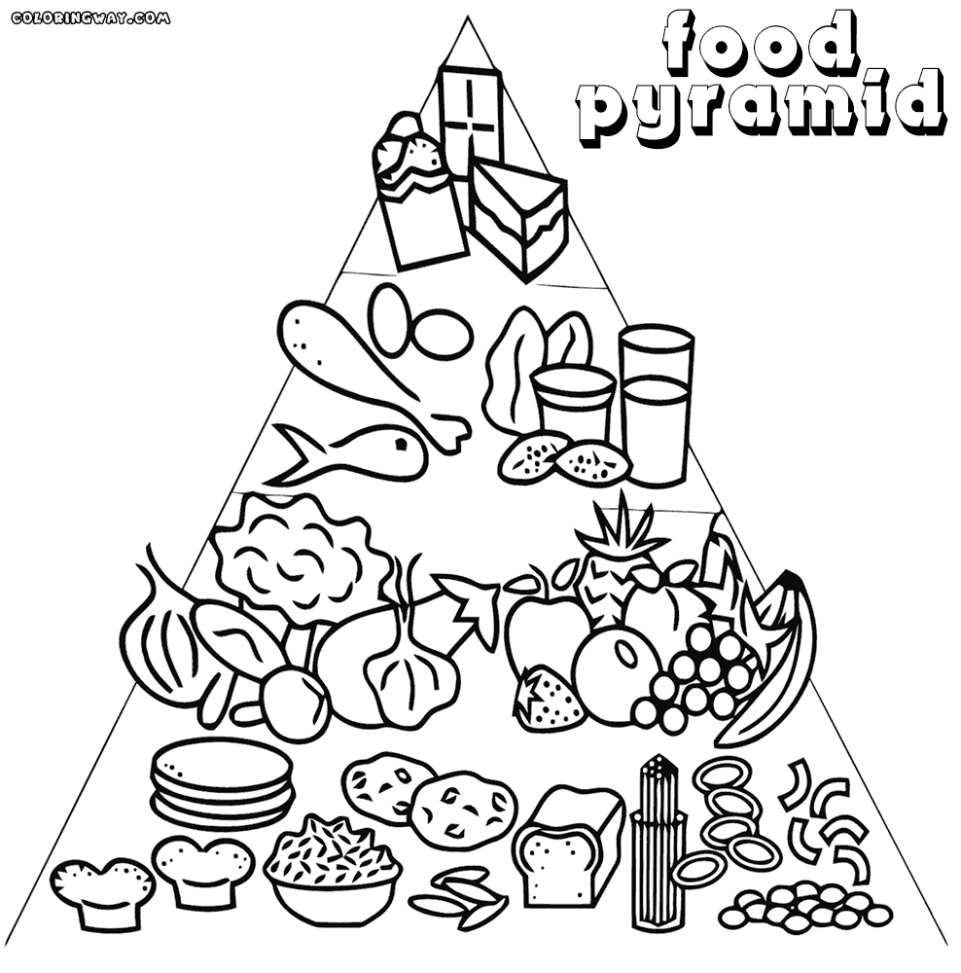

**Подготовила учитель английского языка**

**Абдулаева Аминат Магомедовна**.

Урок английского языка по теме "Типичная английская еда". 7-й класс.

**Цель урока:** Обучение устной монологической речи по теме: “Типичная английская еда”

**Задачи урока:**

1. Образовательные:

* Повторение лексики по теме: “Еда”
* Обогащение и усложнение лексического запаса при ведении монологических высказываний об английской кухне
* Расширение словарного запаса
* Тренировка навыка аудирования и чтения
* Умения отвечать на поставленные вопросы

2. Воспитательные:

* Развитие интереса к изучению страны, изучаемого языка
* Уважение к культуре других народов

3. Развивающие:

* Развитие творческой фантазии
* Развитие познавательного интереса

**Предварительная подготовка:**

* Учащиеся готовят оформление рецептов приготовления сэндвича, чая
* Приготовление блюд из продуктов
* Картинки с продуктами

**Оформление:**

* Фотографии фирменных английских блюд
* Готовые блюда, чай

**Форма проведения:** В форме кафе (фуршет).

**Оборудование:**компьютер, мультимедийный проектор, доска, магнитофон, аудиозаписи ,презентация Microsoft Power Point.

Ход урока

**Слайд 1 the theme of the lesson**

Слайд 2

**T: Listen, read and repeat.**

[i:] – sweet, tea, tea-break, Easter, mean, meat, cheese, pizza

[i]- biscuit, foreigner, tin, chips, Christmas

[ai]- pie, slice, kind, type, like, knife,

[æ]- sandwich, salad, Valentine’s Day, have, apple

[ei] – cake, break, made, mayonnaise, plate, table

[λ]- bun, Mother’s Day, others, lunch, discuss, butter

[o]- shop, strong, tablecloth, sausage, teapot, foreigner

[o:] – sort, fork, salt, water, more, before

[u] –pudding, woman, put, full, look

[u:] – tooth, juice, spoon, food, too

[әu]- roll, slow, rose, phone, know

Слайд 3

T: Find the words which we can eat and drink

* sweet, tea, cheese, pizza
* biscuit, chips
* pie, slice
* sandwich, salad
* cake, mayonnaise
* bun, butter
* sausage
* salt, water
* pudding
* juice, food
* roll, apple

T: Read the poem about “Five apples”

Слайд 4

T: Answer the questions

1. What do the words “the British have a sweet tooth” mean?  
2. What kinds of sweet things do you know of?  
3. What sweet things do you like?  
4. When do the British eat cakes, biscuits?  
5. When do the British eat more sweet things?

Слайд 5

**T: Find 20 names of food. First read the horizontal (9) lines then read the vertical (11) lines.**

|  |  |  |  |  |  |  |  |  |  |
| --- | --- | --- | --- | --- | --- | --- | --- | --- | --- |
| C | A | T | O | C | F | C | O | N | H |
| E | P | E | R | A | I | H | R | M | O |
| G | P | A | B | K | S | E | A | I | N |
| G | L | A | N | E | H | R | N | L | T |
| M | E | P | E | A | R | R | G | K | Y |
| B | A | N | A | N | A | Y | E | B | J |
| N | U | T | Z | L | E | M | O | N | A |
| C | H | O | C | O | L | A | T | E | M |
| H | O | N | E | Y | A | V | Q | W | E |
| I | C | E | C | R | E | A | M | P | A |
| P | I | Z | Z | A | R | B | U | L | T |
| S | A | N | D | W | I | C | H | R | L |

Слайд 6

T: Checkyouranswers. (Демонстрация дублирующего слайда с правильными ответами)

|  |  |  |  |  |  |  |  |  |  |
| --- | --- | --- | --- | --- | --- | --- | --- | --- | --- |
| C | A | **T** | O | **C** | **F** | **C** | **O** | N | H |
| **E** | P | **E** | R | **A** | **I** | **H** | **R** | **M** | O |
| **G** | P | **A** | B | **K** | **S** | **E** | **A** | **I** | N |
| **G** | L | A | N | **E** | **H** | **R** | **N** | **L** | T |
| M | E | **P** | **E** | **A** | **R** | **R** | **G** | **K** | Y |
| **B** | **A** | **N** | **A** | **N** | **A** | **Y** | **E** | B | **J** |
| **N** | **U** | **T** | Z | **L** | **E** | **M** | **O** | **N** | **A** |
| **C** | **H** | **O** | **C** | **O** | **L** | **A** | **T** | **E** | **M** |
| **H** | **O** | **N** | **E** | **Y** | A | V | Q | W | **E** |
| **I** | **C** | **E** | **C** | **R** | **E** | **A** | **M** | P | **A** |
| **P** | **I** | **Z** | **Z** | **A** | R | B | U | L | **T** |
| **S** | **A** | **N** | **D** | **W** | **I** | **C** | **H** | R | L |

Слайд 7

**T: Read the text about British people and fill in necessary words to the text.**

|  |
| --- |
| Sweet tooth, puddings, buns, at school, at home, holidays, Valentine’s day |

The British have a _____. That means that they like eating sweet things like _____ and pies, jams, biscuits and _____, cakes and rolls. For the British, any time is eat-a-sweet time: tea-break _____, break at school, watching TV _____ on a car journey, in the cinema or theatre. During _____ like Christmas and Easter, and on special days like Mother’s Day and _____ they eat even more sweet things.

Слайд 8

**T: Match the different words with their definitions.**

1. milk
2. anapple
3. a dinningroom
4. a lunch
5. anEnglishtea
6. a secondbreakfast
7. where pupils go during break to eat
8. it grows on the apple -tree
9. itgives a cow
10. a teawithlemon

Слайд 9

**T: Checkouranswers. (Демонстрация дублирующего слайда с правильными ответами)**

1. milk d) it gives a cow
2. an apple c) it grows on the apple -tree
3. a dinning room b) where pupils go during break to eat;
4. a lunch a) a second breakfast
5. an English tea e) a tea with lemon

T: Let’s have a rest. The play “Potatoes”

Слайд 10

**T: Try to match the words with the pictures as in example.**

|  |  |
| --- | --- |
| coffee | 1 кофе |
| sandwich | 2 сэндвич |
| cheese | 9 сыр |
| strongtea | 8 крепкий чай |
| fish | 3 рыба |
| pudding | 4 пудинг |
| egg | 5 яйцо |
| porridge | 6 каша |
| juice | 7 сок |

Слайд 11

**T: Let’s check your answers.** (Демонстрация дублирующего слайда с правильными ответами)

Слайд 12

**T: Read the text.**

English Sandwiches and English Tea

A lot of people in England eat sandwiches for their lunch. There are a lot of sandwich shops in London. You can buy all sorts of sandwiches in these shops. You can get meat sandwiches, or salad sandwiches, or meat –and –salad sandwiches. And you can get cheese, egg or fish sandwiches. You can even buy fruit sandwiches. Each sandwich has 2 thin slices of bread. You put butter and meat between the 2 slices. Lots of foreigners don’t like English sandwiches. They like the kind of sandwich we call a roll. Some foreigners don’t like English tea, either. English tea is very strong. The Englishmen drink a lot of tea. They drink it with lemon, we drink tea with milk, so it is called the Russian tea.

Слайд 13

**T: Is the information in these sentences True or False?**

1. There are a lot of sandwich shops in London (t)
2. You can’t buy all sorts of sandwiches in these shops (f)
3. You can even buy milk sandwiches (f)
4. Each sandwich has 2 thin slices of bread (t)
5. You put butter and meat between the 3 slices. (f)
6. English tea is very strong. (t)
7. We drink tea with meat, so it is called the Russian tea. (f)

**Подведение итогов:**

**T: Today we’ve remembered the names of different food, and we’ve spoken about English typical food**

Слайд 14

Home-task: What would you say to your English pen friend about typical Russian food? Makeupashortstory. Ex.41 p.135

**Рефлексия:** Спрашиваю у учеников .Что понравилось? Что получилось , а что нет ? и т.д.

**Домашнее задание :**Выучить новые слова и придумать предложения .

T: The lesson is over. Good-bye.