ГКОУ РД «Щедринская СОШ Тляратинского района»

ЦОДОУ ЗОЖ

Мероприятие по английскому языку в 8 классе

« **Sportinourlive**»

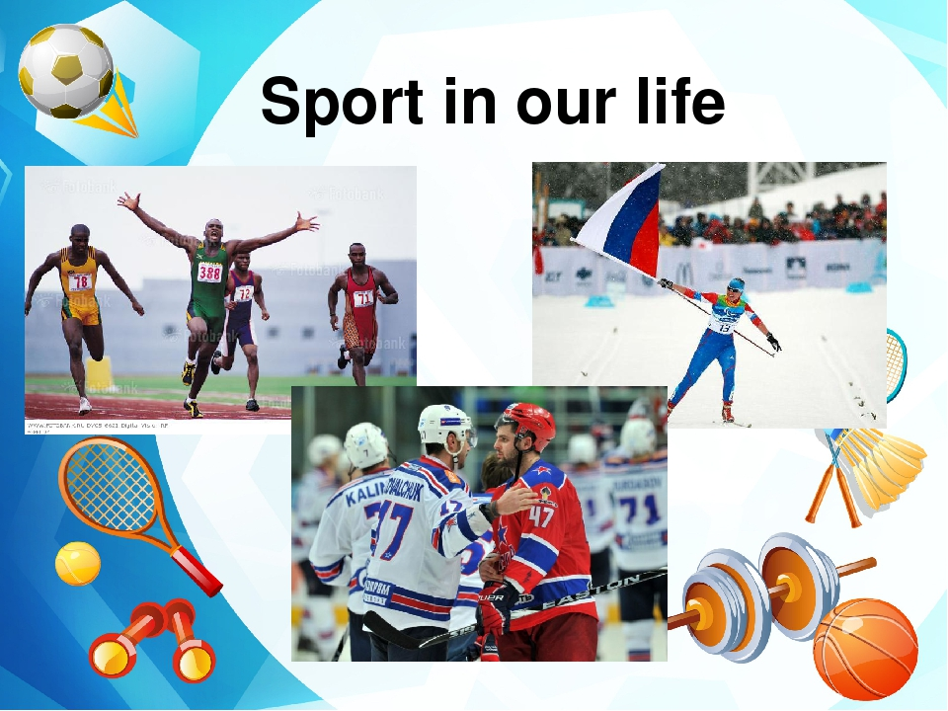

Подготовила учитель английского языка:

Абдулаева Аминат Магомедовна.

**Конспект мероприятия в 8 классе по теме «Спорт», «Спорт в нашей жизни».**

**Цель мероприятия** : расширение и углубление коммуникативной компетенции, развитие навыков аудирования и говорения, обеспечивающих устное общение как в диалогической, так и в монологической формах.

**Оборудование:** аудиозаписи с текстом и музыкальным фоном, раздаточный материал с упражнениями, слайдшоу изображений по различным видам спорта и фотографий известных спортсменов мира, России, и т.д.

**Ход мероприятия :**

1. Начало урока. (Приветствие, беседа по теме). At what time did you get up? Did you do morning exercises? Do you do morning exercises every day?
2. Listen to a short recording. (Запись с футбольного матча).

What competition is it? – It is a football match.

What teams are playing? – England and Scotland.

Do they usually play well? – Yes, they do.

How are they playing today? – England isn’t playing very well, but Scotland is playing badly.

1. So what are we going to talk about at our lesson? –About sport.

Sport is a wonderful world, isn’t it?

Let’s brush up our phonetics. (Чтение и воспроизведение стихотворения «Sport». Формирование произносительных  навыков.

Listentothepoem "Sports", thenreadit (хоровая и индивидуальная  работа).

Sport is fun for girls and boys.                 You can swim and play football,

It’s much better than the toys.                 Hockey, tennis, basketball.

You can sledge, and ski, and skate,          You can jump and can run.

And play snowballs with Kate.                 You can have a lot of fun.

**Упр. 2.** Read as quickly as possible.

1) Bob, Bob's dog, Bob's dog got, Bob's dog got a pot, Bob's dog got a  hot pot, Bob's dog got a hot pot of porridge. Bob's dog got a hot pot of porridge and some chops.

2) Football, more football, basketball more than football, adore basketball more than football, boys adore basketball more than football, tall boys adore basketball more than football. All tall boys adore basketball more than football. Almost all tall boys adore basketball more than football.

**Упр. 3.** Read the sentences. Pay attention to the sounds.

I like watching football. I always watch my local football team when they play at the Sports Centre. I also watch sport on television quite often. And I go jogging every morning.

**Упр. 4.** Mindyourpronunciation:

|  |  |  |  |
| --- | --- | --- | --- |
| **[I]** | **[æ]** | **[ŋ]** | **[aI]** |
| f**i**gure  tenn**i**s  hock**ey**  k**i**ckbox**i**ng  g**y**mnast**i**cs  voll**ey**ball  bask**e**tball | b**a**dminton  st**a**dium  **a**thletics  h**a**ndball  gymn**a**stics | swimmi**ng** boxi**ng**skati**ng**         skii**ng**  cycli**ng**  wrestli**ng**  ridi**ng** jumpi**ng** surfi**ng**         runni**ng** | r**i**ding c**y**cling  **i**ce hockey pr**i**ze  w**i**de |

**Упр. 5.** Mindyourstress:

|  |
| --- |
| 'Badminton, 'volleyball, 'basketball, 'handball, 'baseball, 'football. |
| Ath'letics, ae'robics, gym'nastics. |
| 'Ice'hockey, 'ice-'skating, 'figure-'skating, 'kick-'boxing, 'water-'skiing, 'wind-'surfing. |

1. Активизация ЛЕ, использование предлогов atthe… inthe … onthe…

**Упр. 6.**Make upas many nouns as it is possible:

|  |  |
| --- | --- |
| foot | ball |
| hand | skating |
| table | boxing |
| volley | tennis |
| base | riding |
| ice | surfing |
| figure |  |
| horse |  |
| wind |  |
| kick |  |

**Упр. 7.**  Match the sports and the places:

|  |  |
| --- | --- |
| **SPORTS** | **PLACES** |
| swimming | stadium |
| icehockey | skatingrink |
| athletics | pool / lake |
| rollerskating | river / sea |
| figureskating | mountains |
| crosscountryrunning (кросс) | fields |
| cycling / skiing | forest |
| riding | street |
| tennis | sportground |
| waterskiing (водные лыжи) | court |
| windsurfing (катание на доске под парусом) | gym |
| surfing (катание на доске по волнам) | sea |

Swimming – in the pool. Ice hockey – on the skating – rink. Athletics –at the stadium, in the gym. Cross – countryrunning – inthefields  etс.

1. Work in pairs. Read the definitions and say what sports they are. Ex. 8.

Read and say what sports these people are talking about.

1) "A round ball is used in this game. Two teams of 11 players kick it. They are not allowed to handle (братьруками) the ball."

2) "To keep fit they travel by bicycle every weekend. They have visited a lot of places. It's their favourite hobby."

3) "It's very popular with women. You can do it in a sport centre with music or just follow classes shown on TV."

4) "You can play this game at home or in the gym. You need a partner, a table, a small ball, a net and two small bats (ракетки)."

1. **T:** What indoor sports do you know? What outdoor sports can you name?

Indoor sports                                        Outdoor sports

Basketball                                                Skiing

Table tennis                                                Skating

Gymnastics                                                Russian hockey

Boxing                                                Football

Wrestling                                                Biathlon

Ice hockey                                                Auto sport

And do you like sport? – P1 P2 P3 – Yes/No.

As you see, some of your classmates, like sport, others don’t.

I can suppose that you know many advantages and disadvantages of sport.

Работа в группах. 5-7 минут. Музыкальный фон. На листах цветной бумаги учащиеся записывают

advantages                                            disadvantages

(for sport)                                              (not much interested)

1. **T:** And now try to persuade your classmates that sport is a wonderful world. And others argue that sport has many disadvantages.

Презентация преимуществ и недостатков:

|  |  |
| --- | --- |
| Advantages | Disadvantages |
| P1 People go in for sport because it is fashion. | P1 Sport is dangerous because brings injures |
| P2 It helps you to be healthy, keep fit. | P2 It takes a lot of time. |
| P3 Going in for sports makes people more organized and better disciplined. | P3 You have no friends, only rivals. |
| P4 Sportsmen are famous all over the world. | P4 Famous sportsmen are in public all the time and their fans follow everywhere. |
| P5 Sport takes extra energy |  |
| P6 |  |

1. You’ve got a guest today, who is a world famous sportsman. Ask him  questions about his sport career.

P1 When did you begin to go in for sport?

P2 Who was your first coach?

P3 What competitions did you take part in?

P4 What medals did you win?

Teacher: Is this sportsman a good example for you?

Would you like to become as famous as he/she?

1. Answerthefollowingquestions:
2. Do you go in for sports or are you just a fan?
3. What is your favourite kind of sport?
4. What kind of sport are you keen on?
5. Do you take care of your health?
6. What do you usually do to keep fit?
7. Do you do morning exercises every day?
8. Do you often go to the swimming-pool or the stadium?
9. Do you like winter or summer sports?
10. What sports are popular in your family?
11. Do your friends go in for sports?
12. Would you like to be a professional sportsman?
13. What famous sportsmen do you know?
14. So, is sport really amazing and thrilling? Is sport an essentional part of our life? Would you like to become a professional sportsman? Can we say  that sport is a wonderful world?

P1, P2 – Yes. Sport is a wonderful world.

1. Homework: read the text “Sport”, be ready for the discussion to the topic.

SPORT

Sport plays a very important role in our life. It is popular among  young and old people. It helps them to keep fit, be healthy and strong.   Going in for sports makes people more organized and better disciplined     in their activities. A lot of people go in for sport. Some of them devote    their lives to sport. They train themselves in sports clubs and sections. All  big sport is professional and sportsmen are famous all over the world.    They take part in European and World championships and the Olympic Games in different kinds of sports and they have set many records, won   gold, silver and bronze medals and world's recognition. Some of them are invited to foreign clubs to play for them or to train sportsmen there. Other people play different games, swim, ski, skate, jog, go in for aerobics, body-building, practice various sports at the stadiums and sport-    complexes just for pleasure. Another group of people prefers to watch   sports competitions at a stadium or on TV while sitting in a comfortable arm-chair and listen to sports news or read about them in newspapers.

Now practically every man has the opportunity to go in for sport.    We have many sports grounds, gyms and swimming-pools. In schools    and colleges physical training is a compulsory subject. At P.T. lessons schoolchildren play volley-ball, basket-ball or other sports games, run,   jump a long way and jump high, ski and go in for gymnastics. Different competitions are held at schools where schoolchildren try to get good   results or win.

The most popular winter and summer outdoor sports in our country   are track - and - field, skiing, football, skating, ice hockey, shooting. Wrestling, boxing, basket-ball, volley-ball, fencing, weightlifting arefavourite among indoor sports.

**Рефлексия:** Спрашиваю у учеников .Что понравилось? Что получилось , а что нет ? и т.д.

**Использованная литература:**

1. УМК И. Н. Верещагина, О. В. Афанасьева для V класса школ с углубленным  изучением английского языка, лицеев, гимназий, колледжей. Москва, «Просвещение», 2005.
2. УМК В. Н. Богородицкая для 8 класса школ с углубленным изучением английского языка, лицеев, гимназий, колледжей. Версия, 2006.
3. О. В. Афанасьева, И. В. Михеева учебник для общеобразовательных учреждений, 5-е издание. Москва, «Дрофа», 2010